Techniken on 4th KYU

STRIKES
Shuto  15 Techniques  Shuto Uchi  Shuto Uke  Yoko Geri  Mawashi Geri  Chusoku  Mawashi Geri  Haisoku  Ushiro Geri | 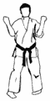  SANCHIN DACHI | 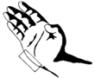  SHUTO  Tegatana or  Knife Hand | 1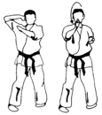  SHUTO SAKOTSU UCHI  right

STRIKES
2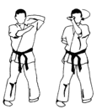  SHUTO YOKO GANMEN UCHI  left | 3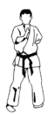  SHUTO UCHI KOMI  right | 4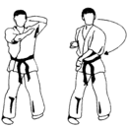  SHUTO HIZO UCHI  left

STRIKES | BLOCKS
5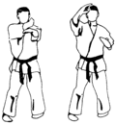  SHUTO JODAN UCHI UCHI  right | 6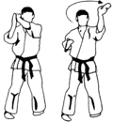  SHUTO JODAN UCHI UKE  left | 7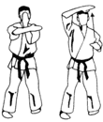  SHUTO JODAN UKE  right

BLOCKS
8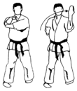  SHUTO CHUDAN UCHI UKE  left | 9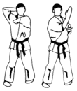  SHUTO CHUDAN SOTO UKE  right | 10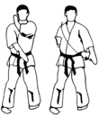  SHUTO MAE GEDAN BARAI  left

BLOCKS
11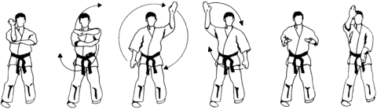
SHUTO MAWASHI UKE (In Sanchin Dachi)
right

KICKS
12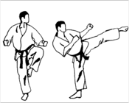  JODAN JOKO GERI  left | 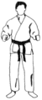  FUDO DACHI | 13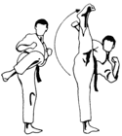  JODAN MAWASHI GERI CHUSOKU  right | FUDO DACHI

KICKS
14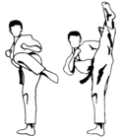  JODAN MAWASHI GERI HAISOKU  left | FUDO DACHI | 15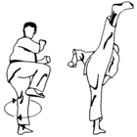  JODAN USHIRO GERI  right | Return to  SANCHIN DACHI

